

**PracticeFit Interoperability Hub Bucket Addition**

Table of Contents

PracticeFit Interoperability Hub Enhancements 2

Purpose 2

General requirements 2

Claim Data of IH addition of Bucket 3

HL7 Import Button in IH Hub 6

Use Case Diagram 8

Logs maintaining for the Process Pending Bucket and Import HL7 feature 9

# PracticeFit Interoperability Hub Enhancements

## Purpose

Purpose of this document is to defined enhancements in PracticeFit.

## General requirements

Over all the flow of the system will remain same, there are some enhancements required in the Interoperability Hub of PracticeFit.

## Claim Data of IH addition of Bucket

The **Claim Data** tab of Interoperability Hub is required to have an addition of new bucket named as **Process Pending** on the left of need to review bucket.

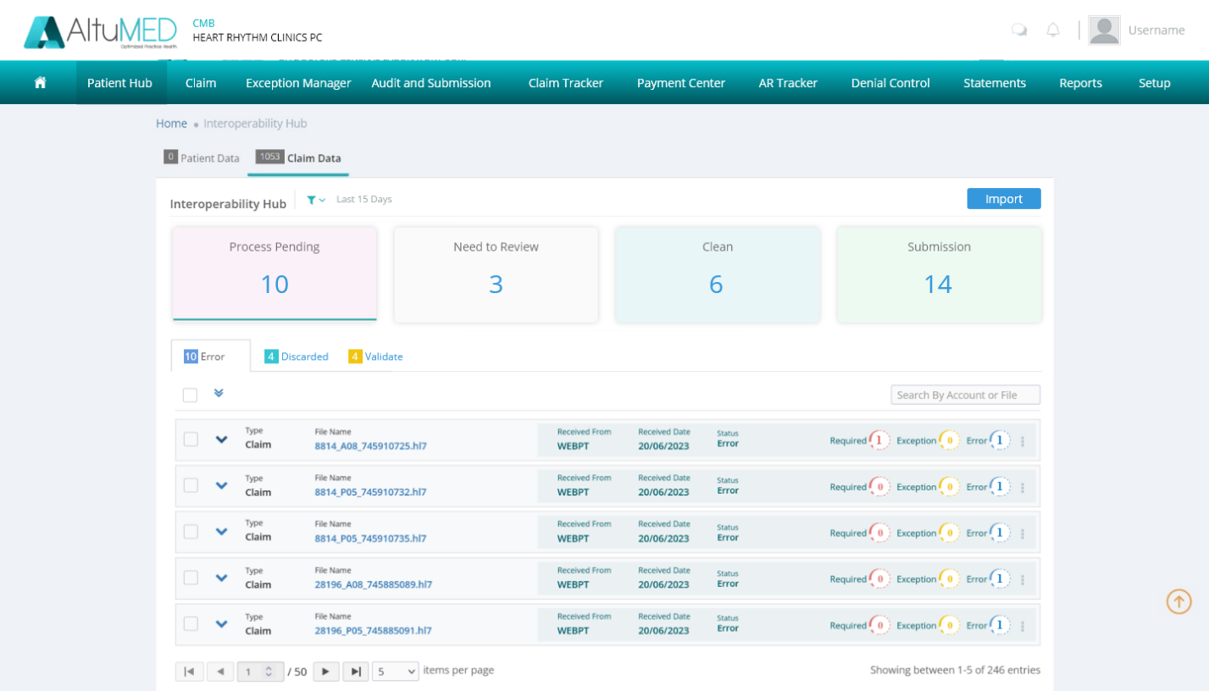

The data shown in this bucket will include the files data that doesn’t enter the system due to some error, Exception, Validation or the data is discarded while processing.

The Bucket will include all the details of the imported files that are having some sort of mapping or error due to which they are stopped in the integration portal.

Bucket will show the overall **count** of the data files that are pending depending upon the top right duration filter as it is working for the other buckets.

User can perform different actions on the bucket data same as done in the integration site.

The data detail will remain same as shown in the integration portal.

Process Pending Bucket will have the following Tabs to view different details.

* **Error**

This Tab will show the files details that are having some mapping errors due to **Required**, **Exception** and **Error** as shown in the integration portal.

All error messages, expanding view details, multiselecting and actions will remain same as working in the integration Portal.

Following data details will be shown in the error details data row.

Type (Claim), File Name (Hyperlinked user can click to download), Received From, Received Date, Status, Required with count, Exception, Error.

There is also a vertical three dots dropdown at the end of each row where the user is shown an option to **Reprocess** or **discard** the file.

Reprocess will simply perform an action to reprocessing the file on the other hand the Discard will change the file status to discard and move the error file to discard tab.

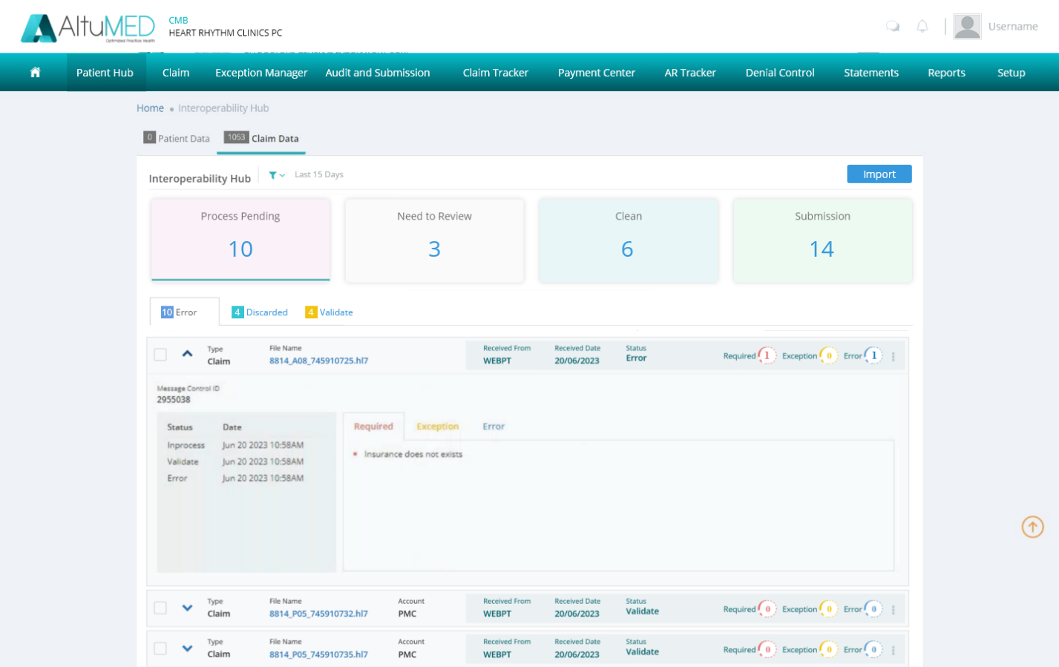

* **Discarded**

It will show the details of the discarded files by the system all the detail and actions will be same as working in the Integration portal.

Following details are required to be shown with each discarded data row.

Type, File Name (Hyperlinked), Received From, Received Date, Status & Message

**Message: Claim already exists in system, Duplicate File is Discarded**

**Note**: All the files with MessageStatus as **Discard** will be shown in this tab.

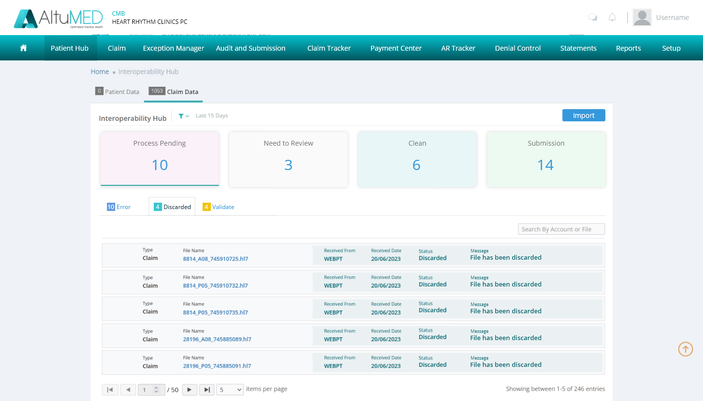

* **Validate**

Files that are not processed due to having some validation issues or invalid format will be shown in this tab.

Following details are required to be shown with each data row.

Type, File Name (Hyperlinked), Received From, Received Date, Status & Message

**Message:** Invalid File Format.

All the files with MessageStatus as **Validate** will be shown in this tab.

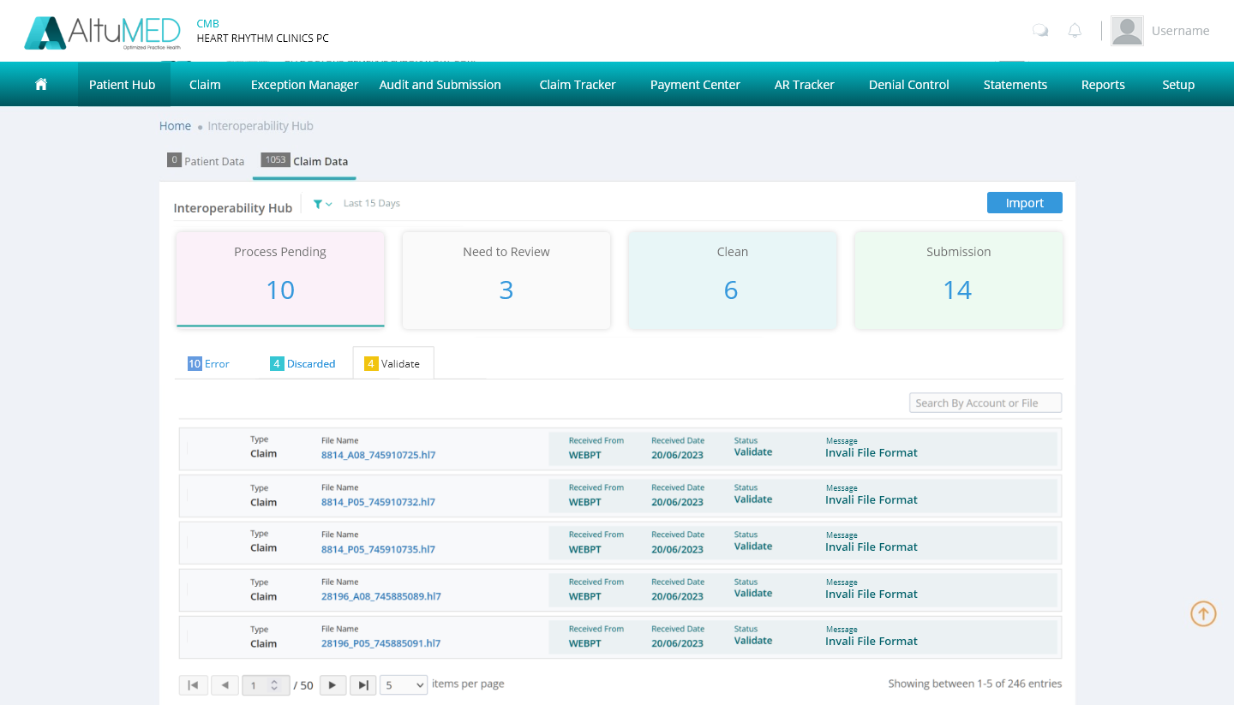

**Important Points:**

* The files data shown in the Process Pending bucket should be Practice Specific that the user is logged in to.
* Search option to search by file name will be given to the user across all the tabs of Process Pending Bucket.
* Each Tab will show the count of the total files data in the respective tab.
* File Name is hyperlinked user can click on the link to download the file.
* Pagination with items count is required in order to avoid any performance issues.

## HL7 Import Button in IH Hub

There is a new button required named as **Import** inside the top right of Claim Data tab of Interoperability Hub.

This button will simply allow user to upload an **HL7** file manually by simply clicking on the import button.

Note: All the validation & checks will work and applied to the imported file and then moved to the respective bucket.

The Successfully Processed Claims will be moved to Need to Review or Clean buckets as per the previous flow.

In case of any error in processing the files will be moved to the Process Pending Bucket in the respective tab where the user can search and find the error for unsuccessful processing.



**Note:** User can upload single or multiple HL7 (max 200 files at a time ) files at a time depending upon the user needs.

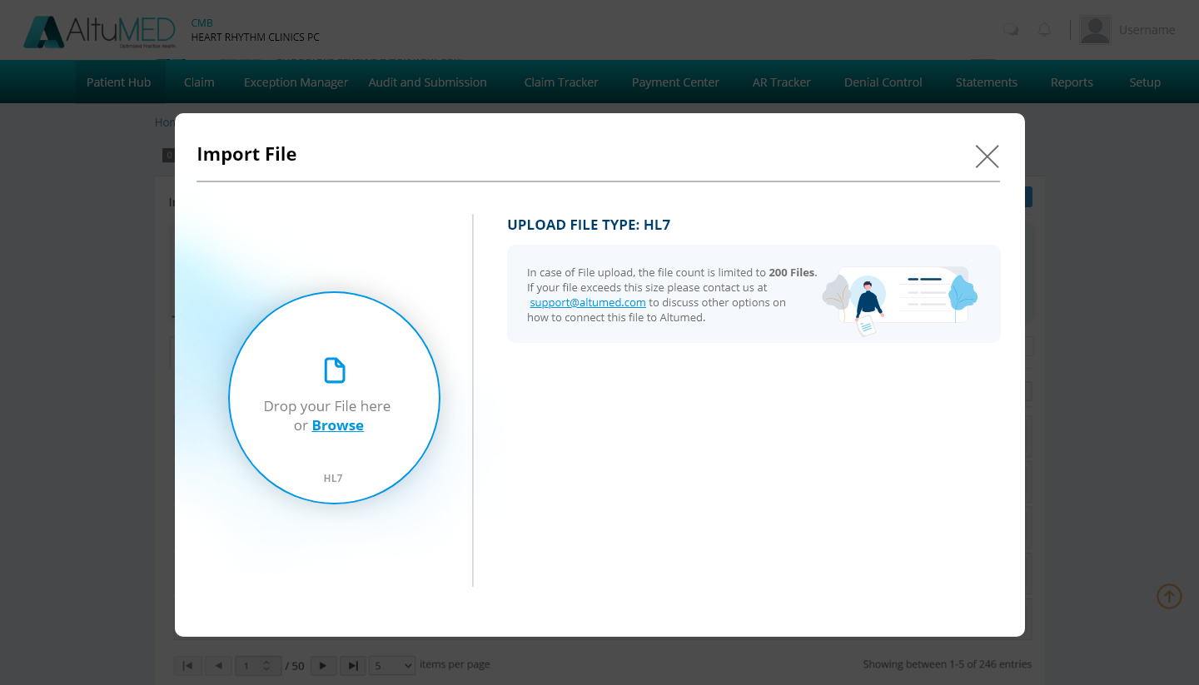

**Note**: When user has selected files or dropped the files for import then said pop up will disappear until the task is completed, so that in the meantime user can perform any other task.

When uploading files is done, a upload summary will appear, which will update the user where files have been moved along with their count.

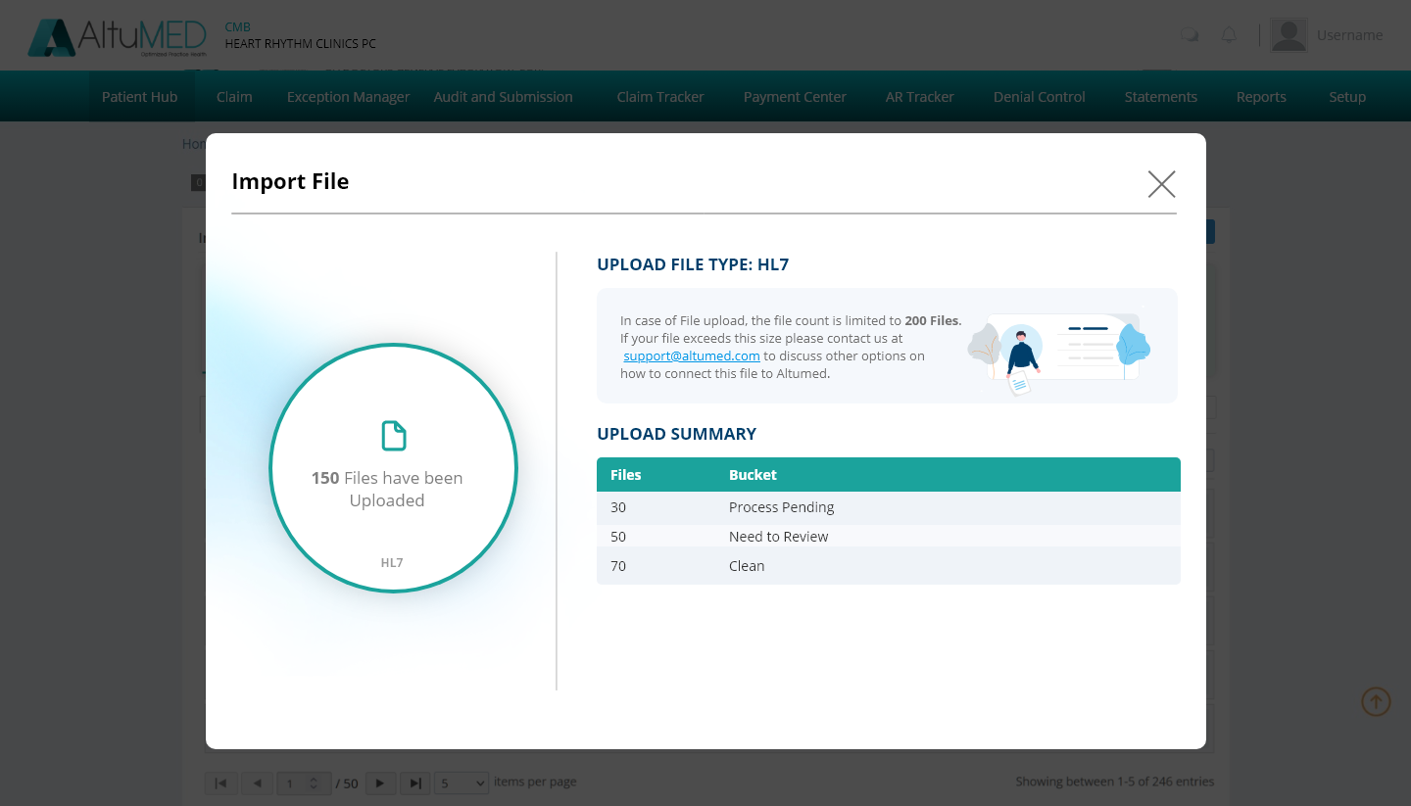

Use Case Diagram**:**

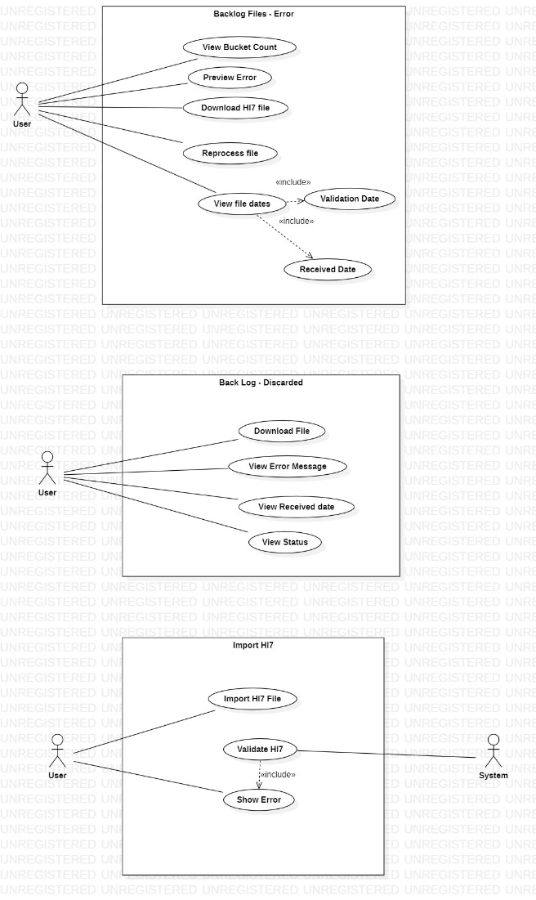

## Logs maintaining for the Process Pending Bucket and Import HL7 feature

Logs should be maintained depending upon the action the user is taking.

Import HL7, Discard and Reprocessing will be requiring to have log to be saved.

The log data will show the Type, File Name, Received From, Received Date, Status & User name of the user as Discarded by, reprocessed by or Imported By respectively.

**Please follow the below link for the user Stories**

[**https://app.box.com/s/2km18ptvjx84avw3ptxqepzv3f4pwdyx**](https://app.box.com/s/2km18ptvjx84avw3ptxqepzv3f4pwdyx)